NAME : GAYATHRI A

EMAIL : [gayathriarumugam1507@gmail.com](mailto:gayathriarumugam1507@gmail.com)

REG.NO : 73152113029

DATE : 12.07.2024

1. 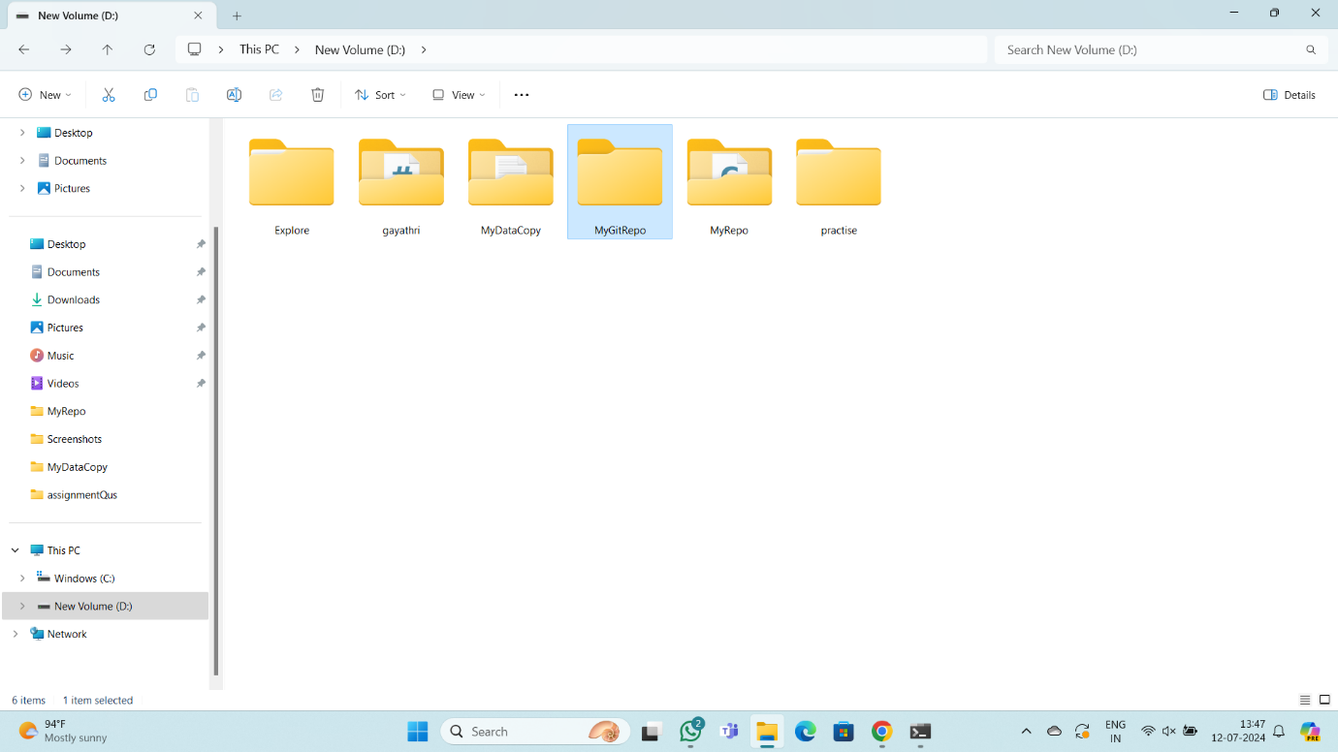Create a new directory and change into it.
2. Use the init command to create a Git repository in that directory.

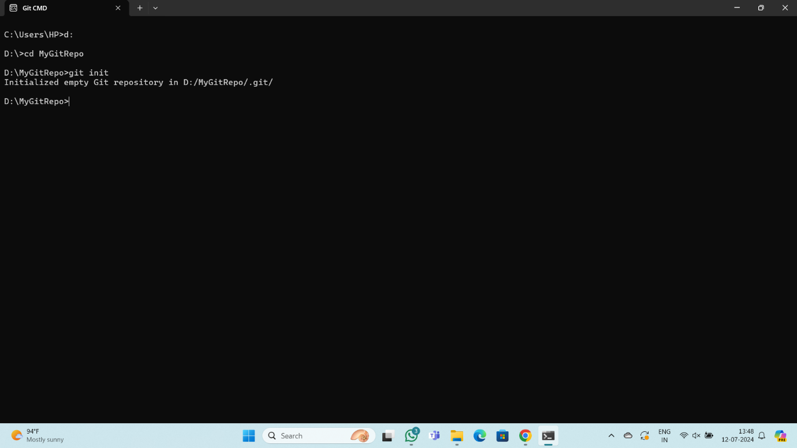

1. 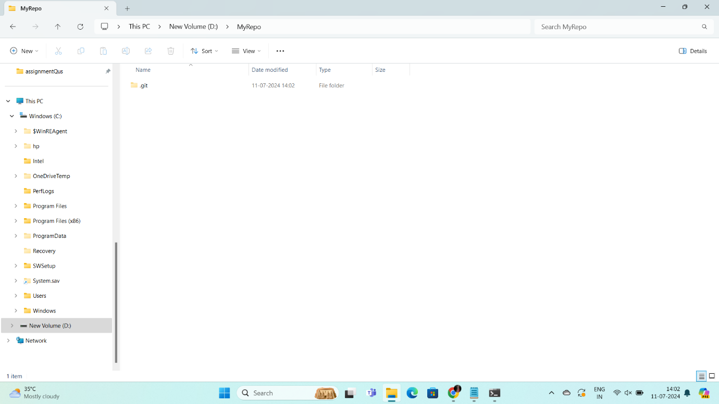Observe that there is now a .git directory.

cs

1. 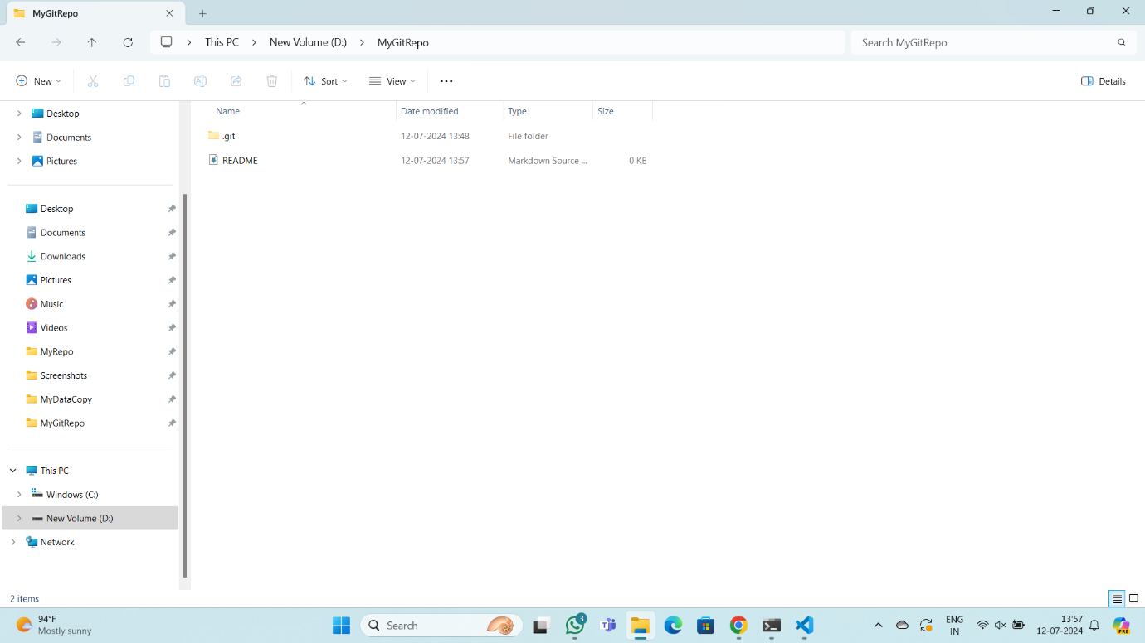Create a README file.
2. 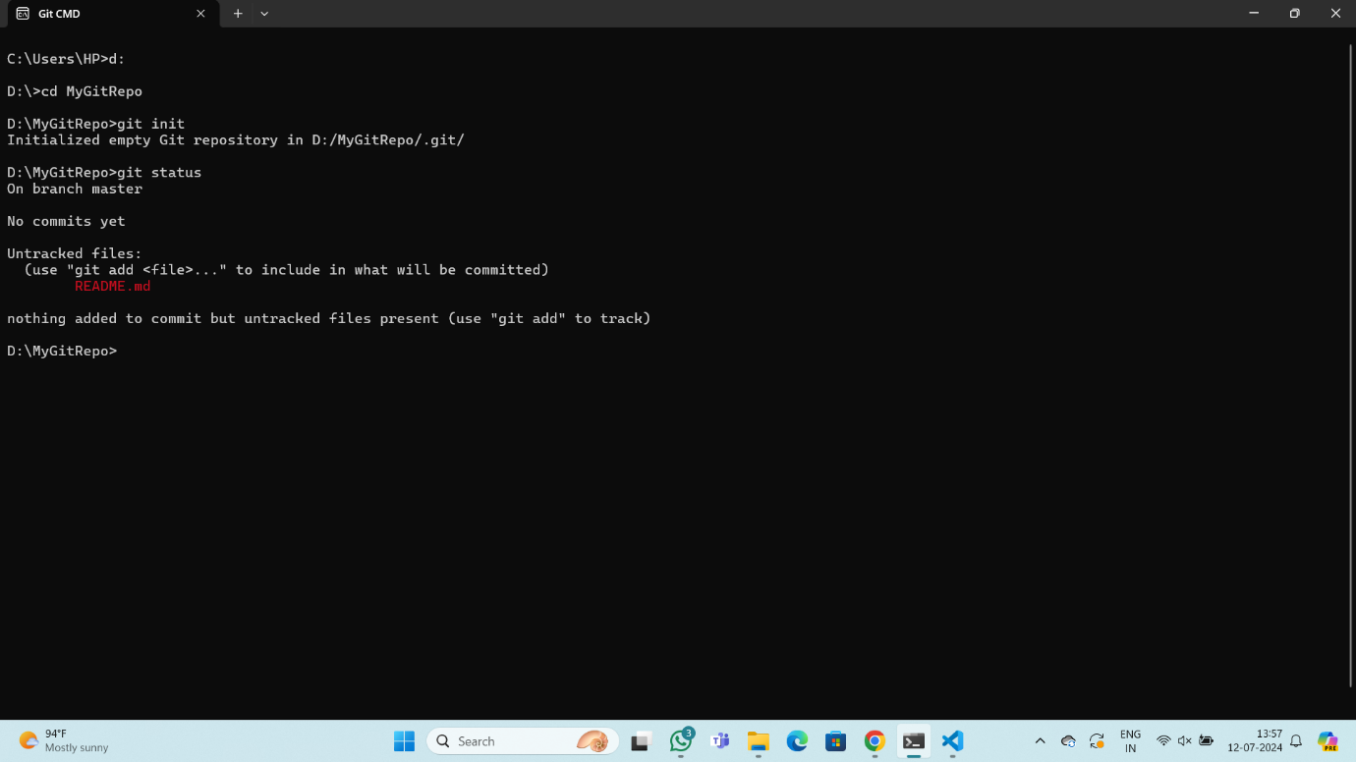Look at the output of the status command; the README you created should appear as an untracked file.
3. 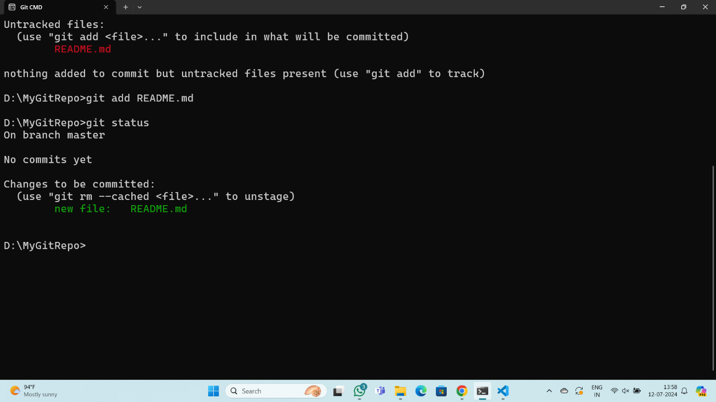Use the add command to add the new file to the staging area. Again, look at the output of the status command.
4. 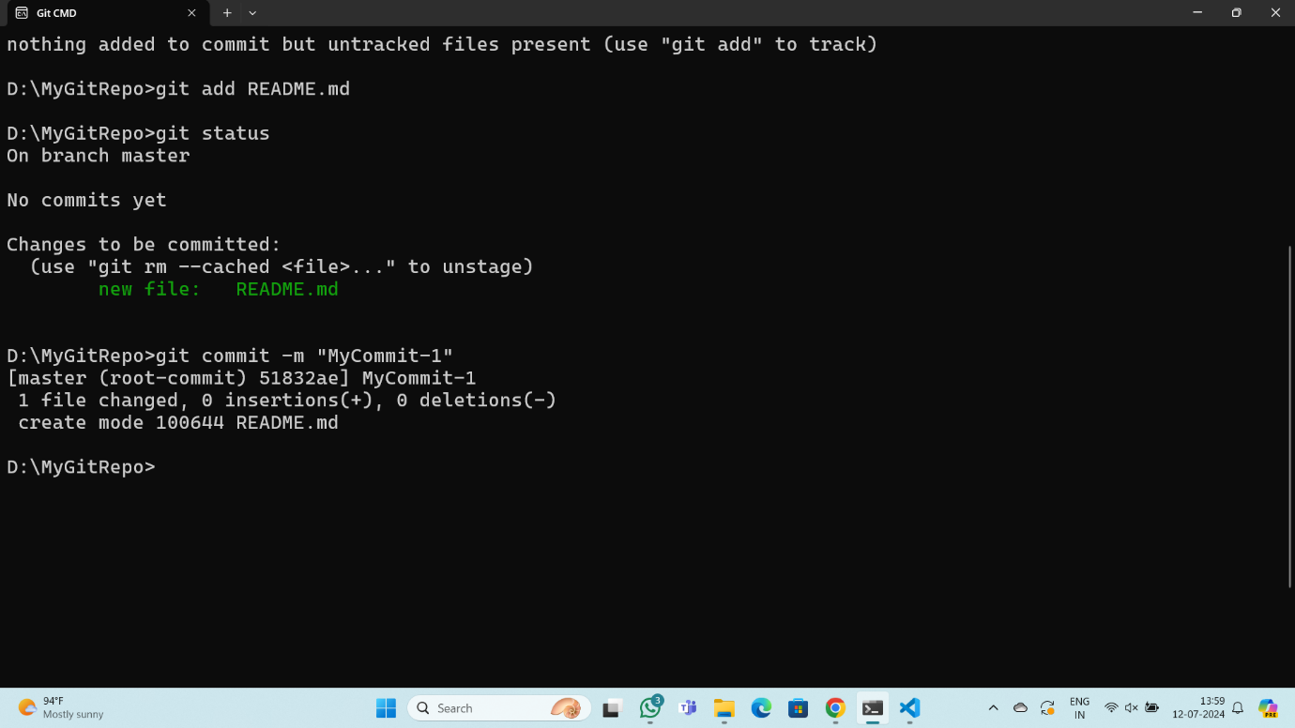Now use the commit command to commit the contents of the staging area.
5. 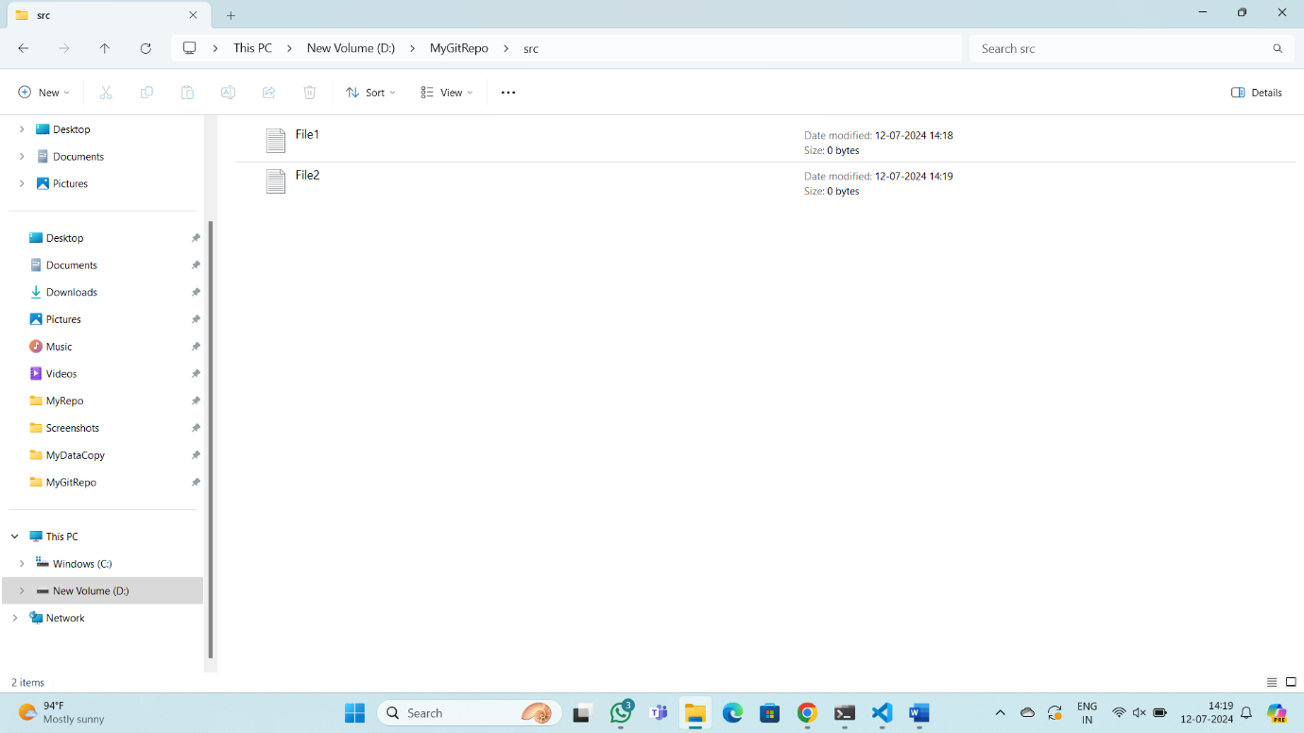Create a src directory and add a couple of files to it.
6. 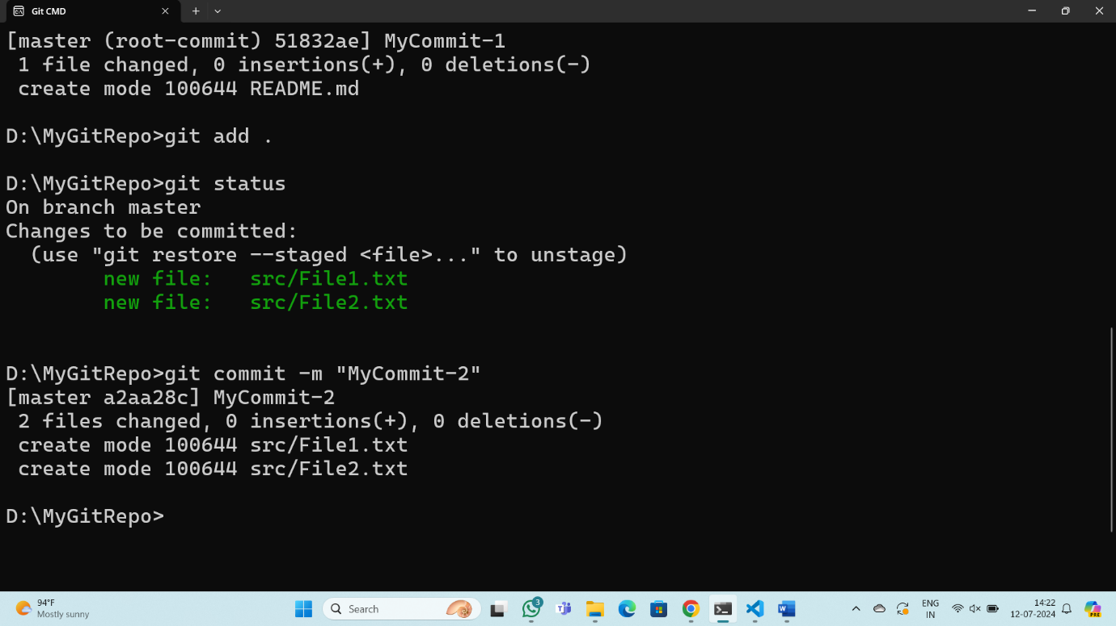Use the add command, but name the directory, not the individual files. Use the status command. See how both files have been staged. Commit them.
7. Make a change to one of the files. Use the diff command to view the details of the change.

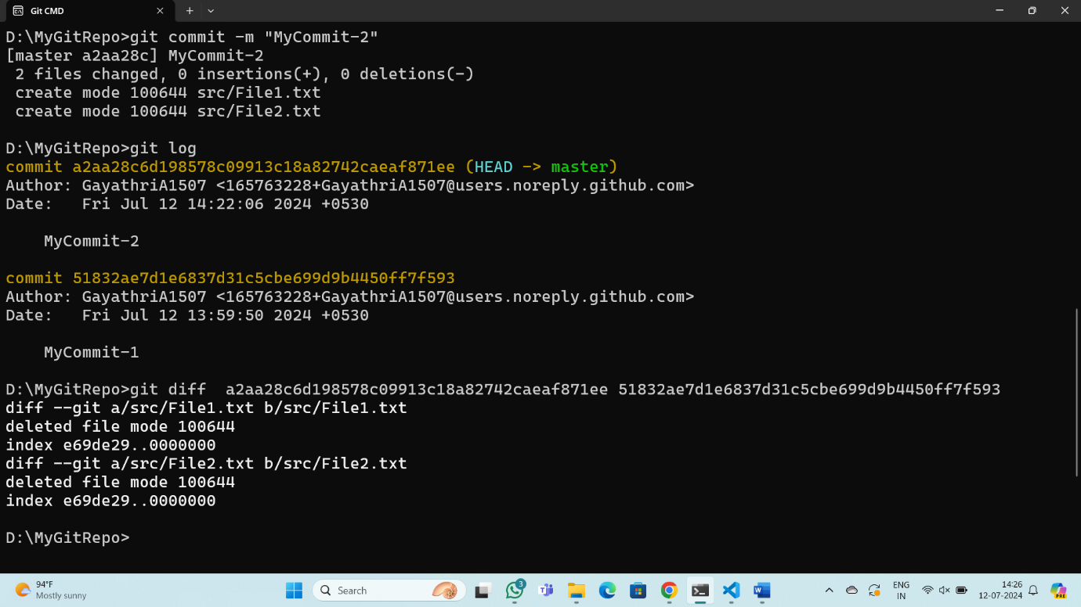

1. 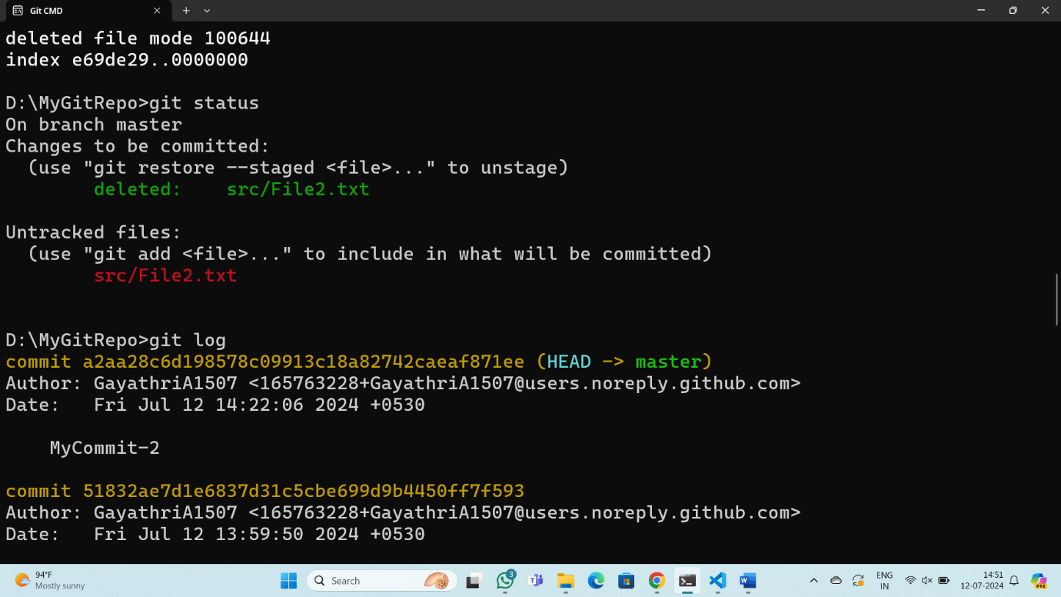Next, add the changed file, and notice how it moves to the staging area in the status output. Also observe that the diff command you did before using add now gives no output. Why not? What do you have to do to see a diff of the things in the staging area? (Hint:review the slides if you can’t remember.)
2. Now – without committing – make another change to the same file you changed in step 10.Look at the status output, and the diff output. Notice how you can have both staged and unstaged changes, even when you’re talking about a single file. Observe the difference whenyou use the add command to stage the latest round of changes. Finally, commit them. You should now have started to get a feel for the staging area.

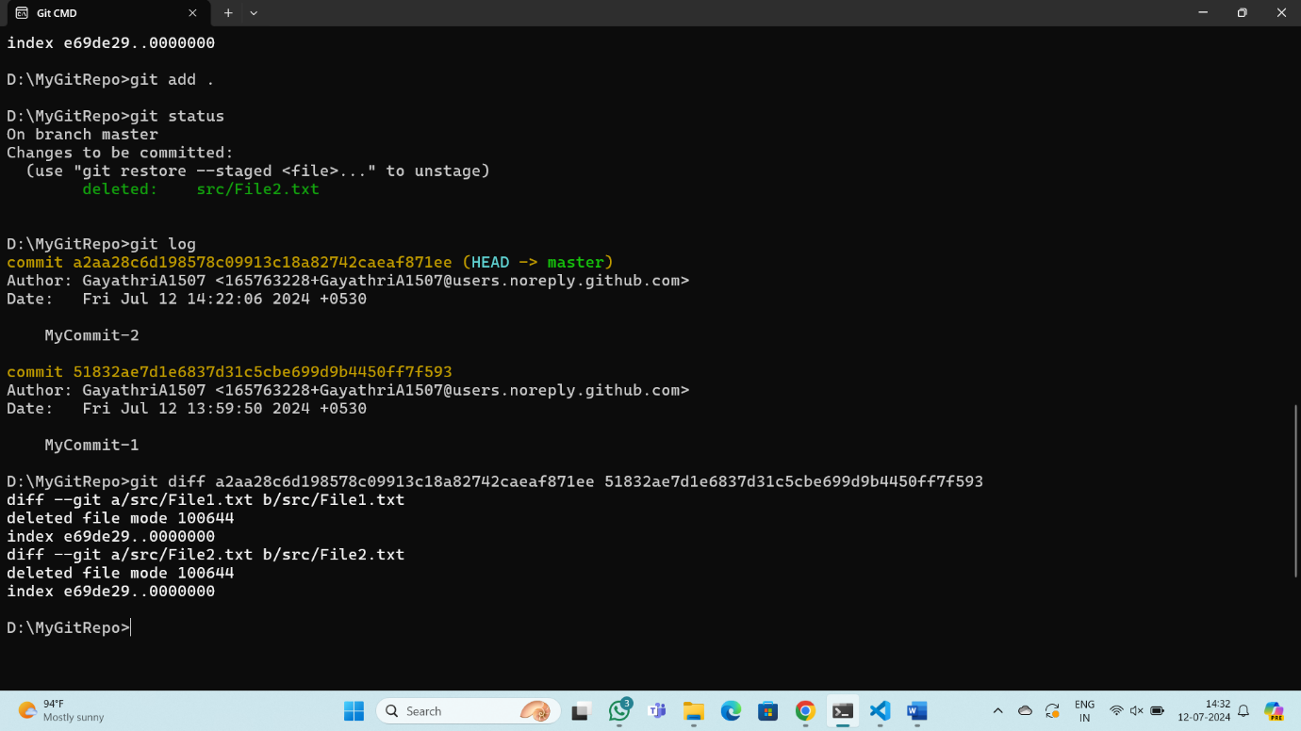

1. 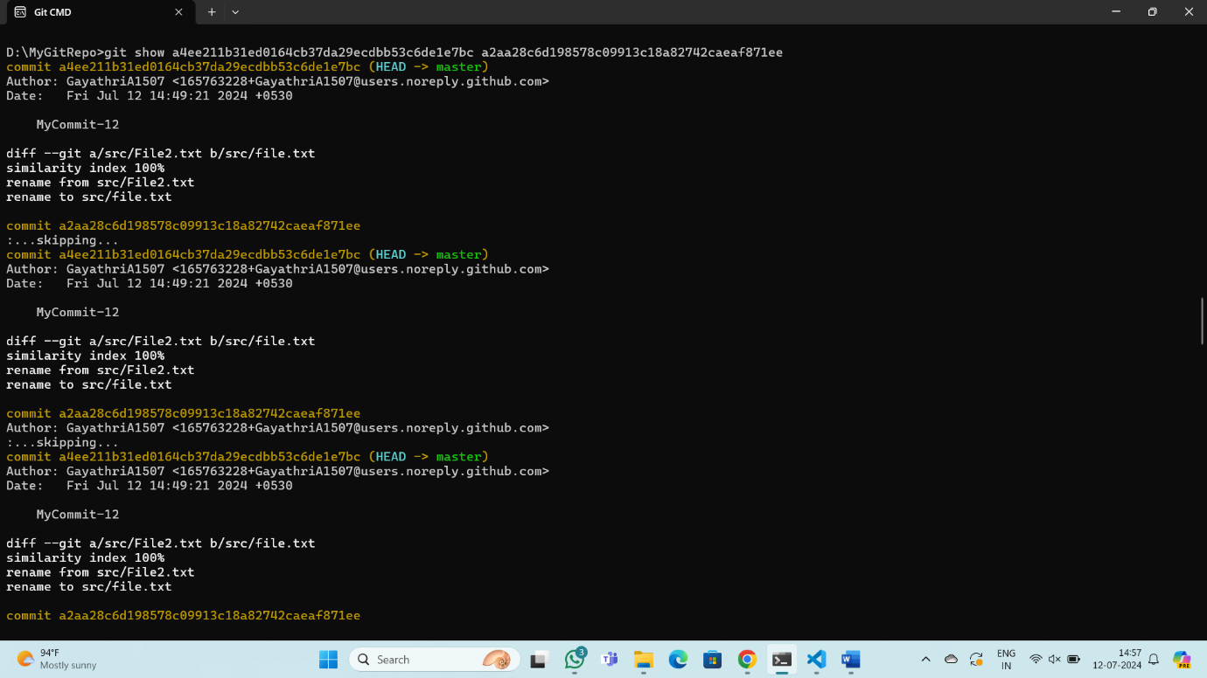Use the log command in order to see all of the commits you made so far.
2. 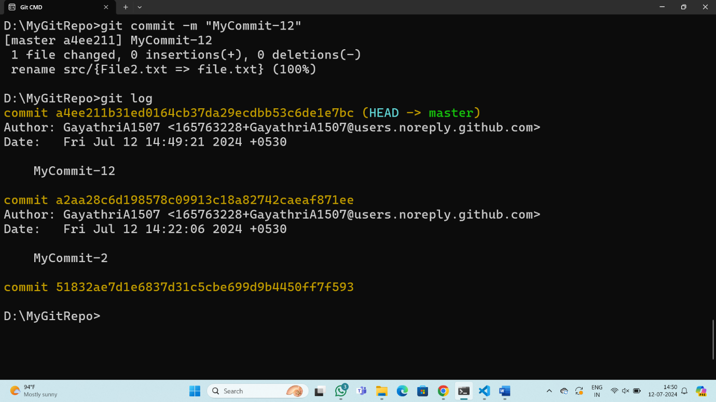Use the show command to look at an individual commit. How many characters of the commit identifier can you get away with typing at a minimum?
3. 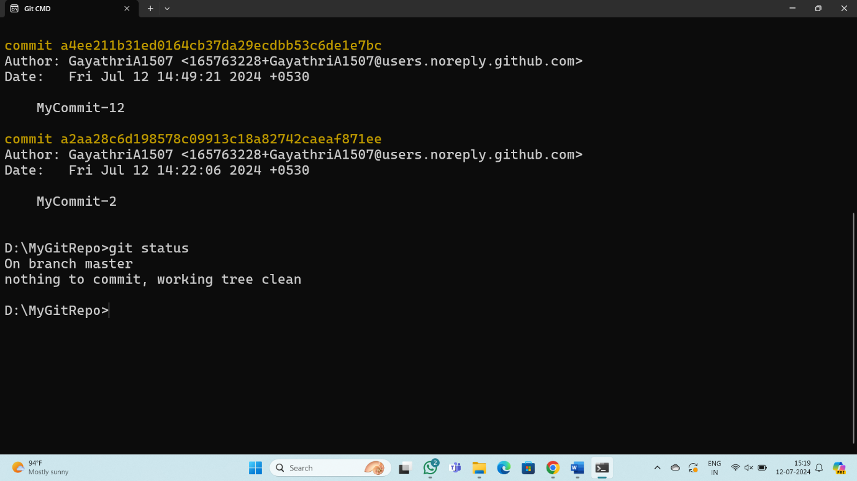Make a couple more commits, at least one of which should add an extra file.

Task -2

1. 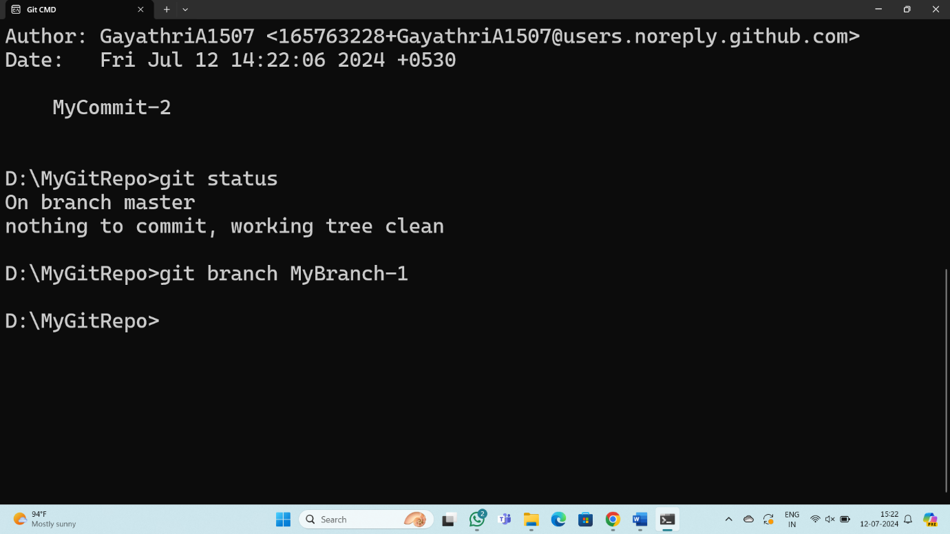Run the status command. Notice how it tells you what branch you are in.
2. 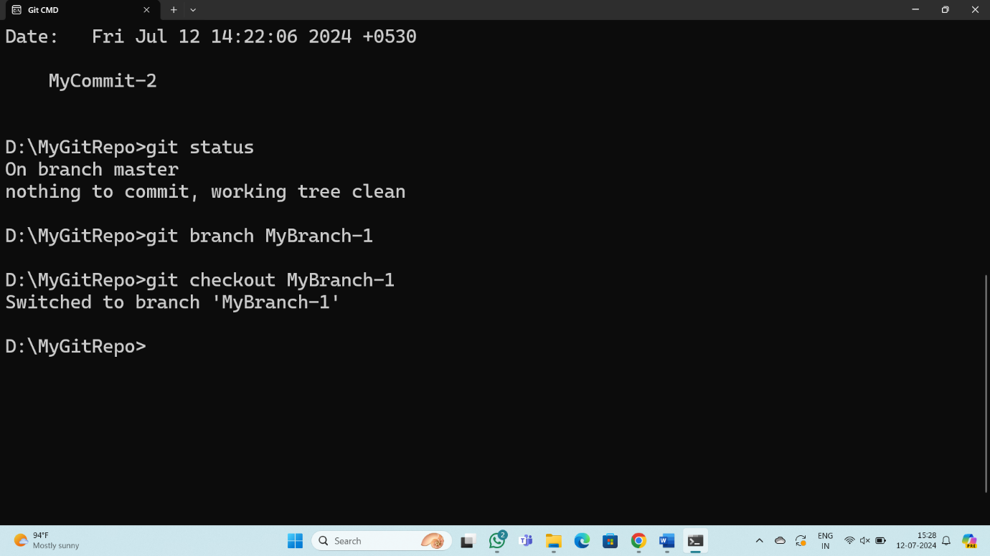Use the branch command to create a new branch
3. 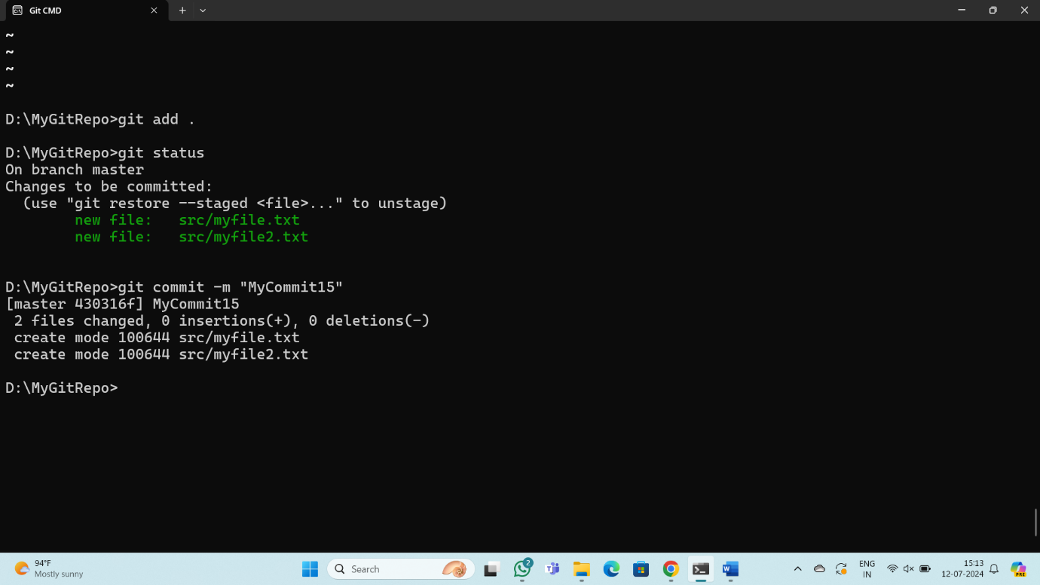Use the checkout command to switch to it.
4. 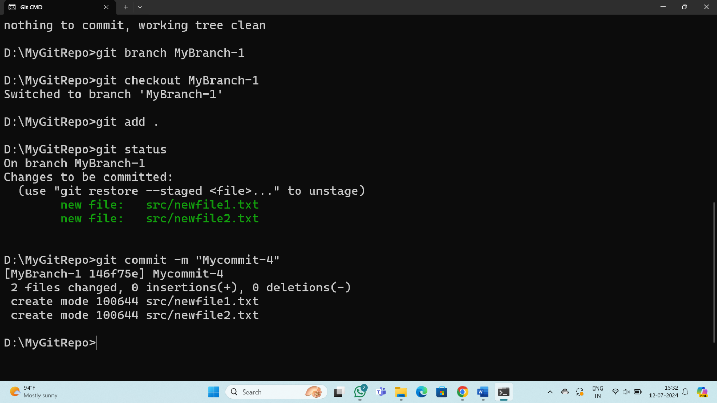Make a couple of commits in the branch – perhaps adding a new file and/or editing existing ones.
5. 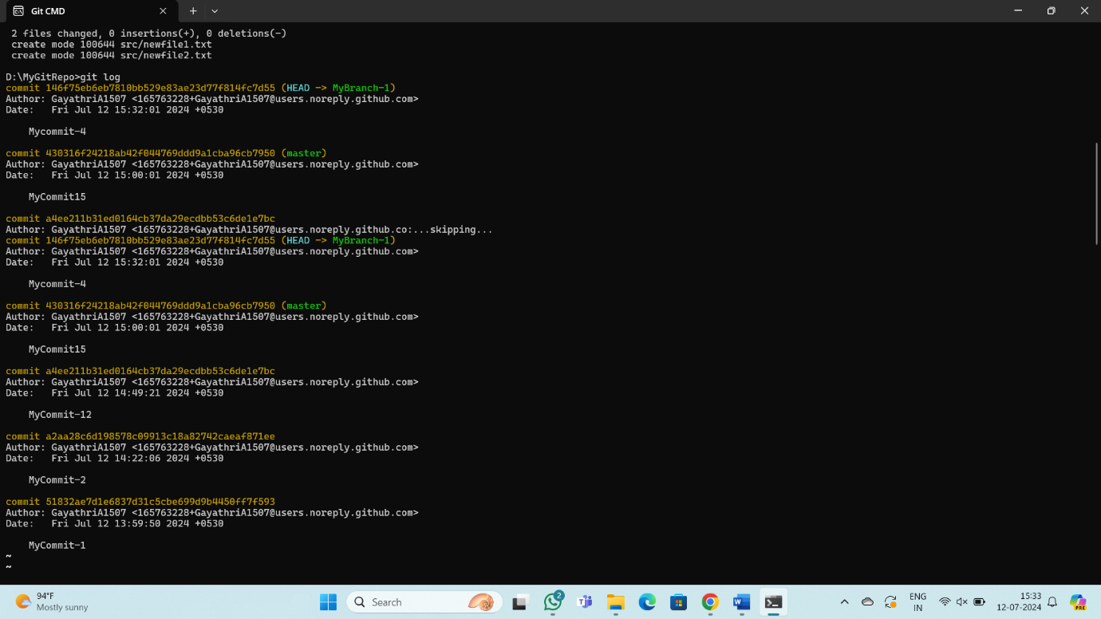Use the log command to see the latest commits. The two you just made should be at the top of the list.
6. 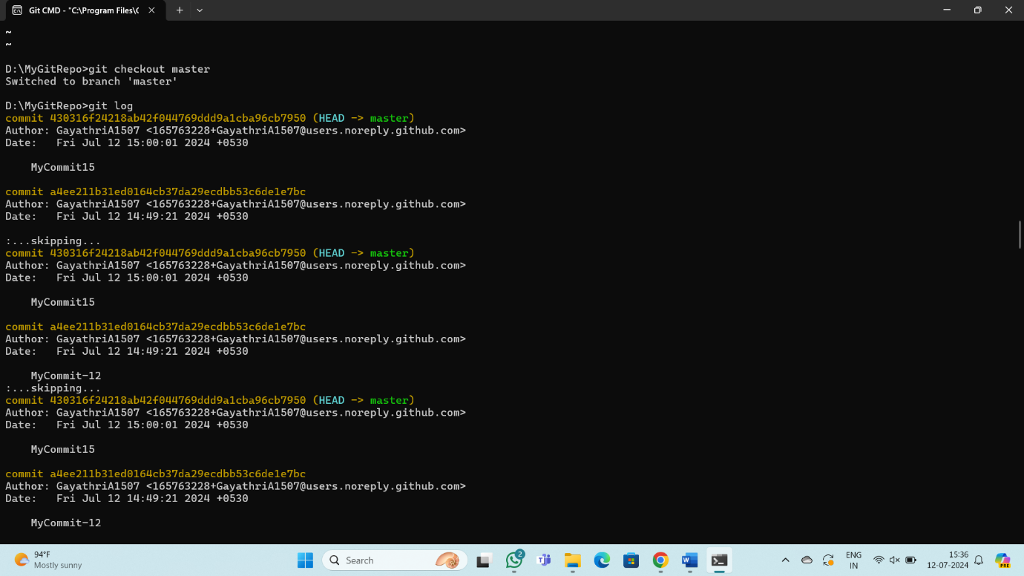Use the checkout command to switch back to the master branch. Run log again. Notice your commits don’t show up now. Check the files also – they should have their original contents.
7. 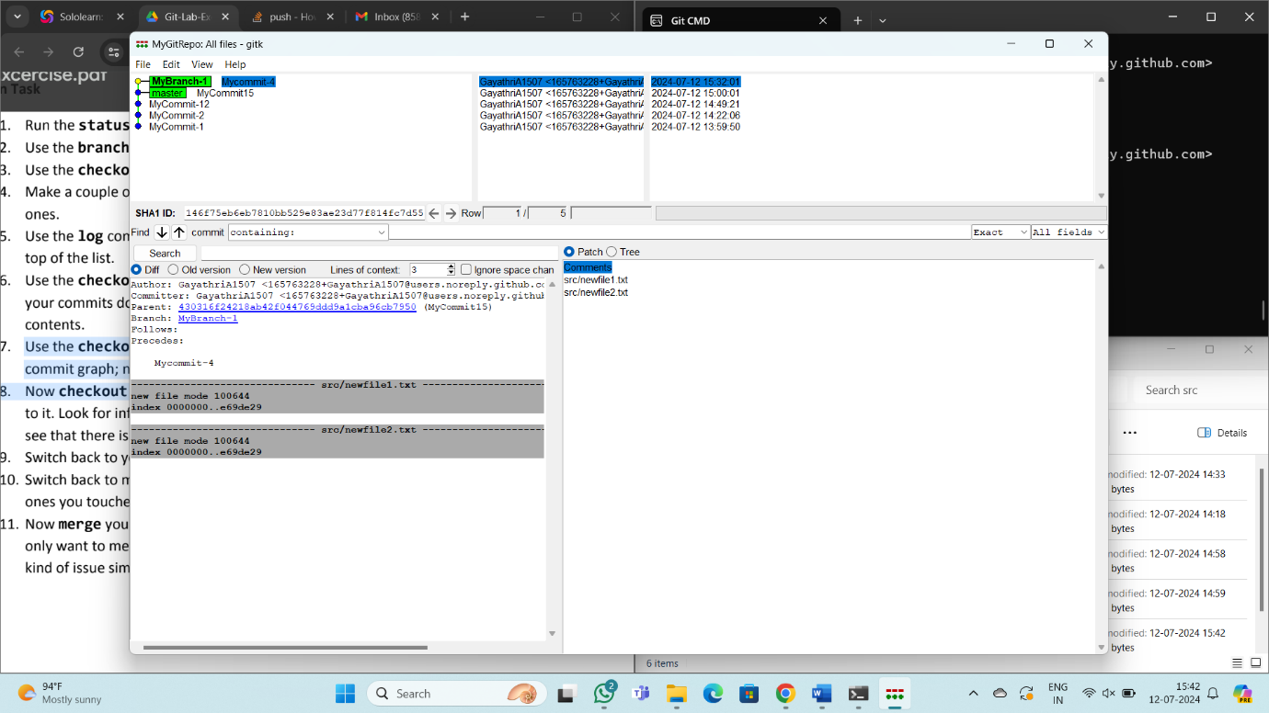Use the checkout command to switch back to your branch. Use gitk to take a look at the commit graph; notice it’s linear.
8. 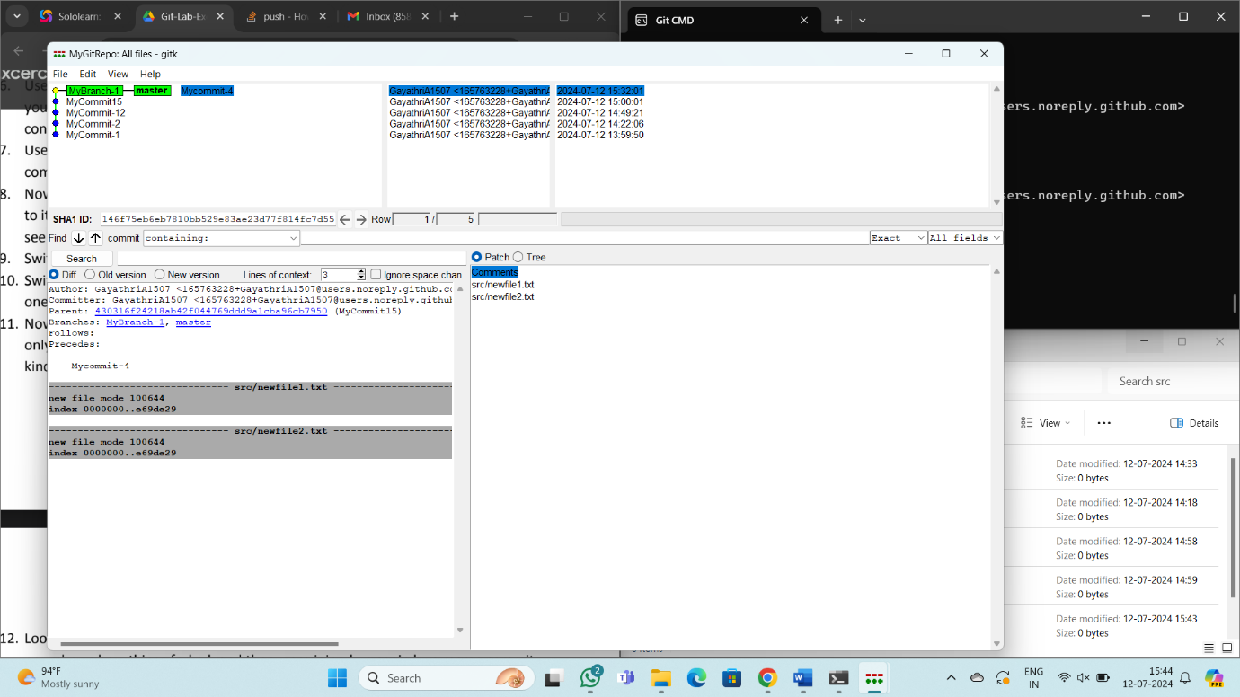Now checkout the master branch again. Use the merge command to merge your branch in to it. Look for information about it having been a fast-forward merge. Look at git log, and see that there is no merge commit. Take a look in gitk and see how the DAG is linear.
9. 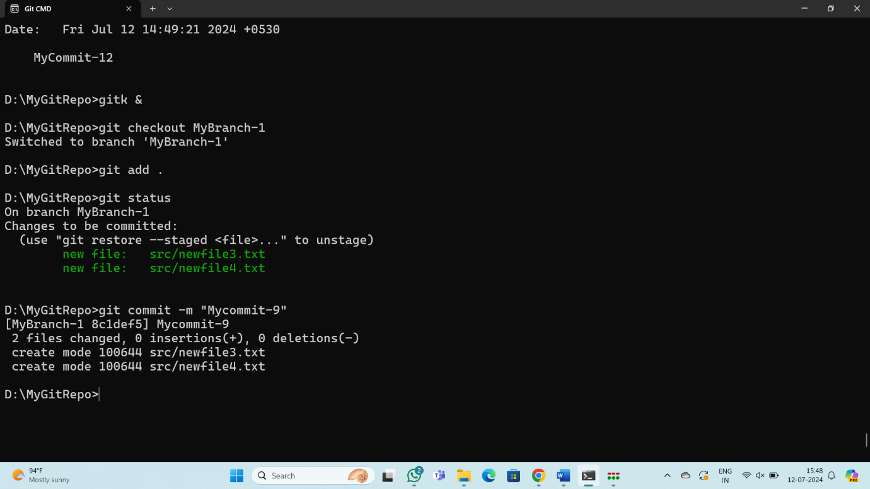Switch back to your branch. Make a couple more commits.
10. 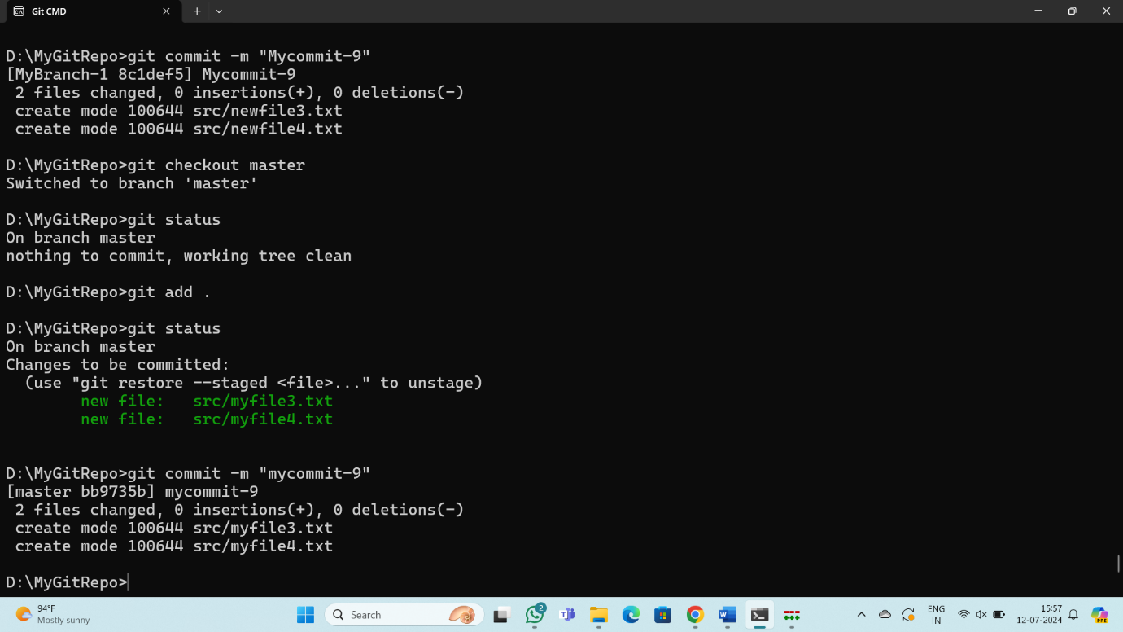Switch back to master. Make a commit there, which should edit a different file from the ones you touched in your branch – to be sure there is no conflict.
11. 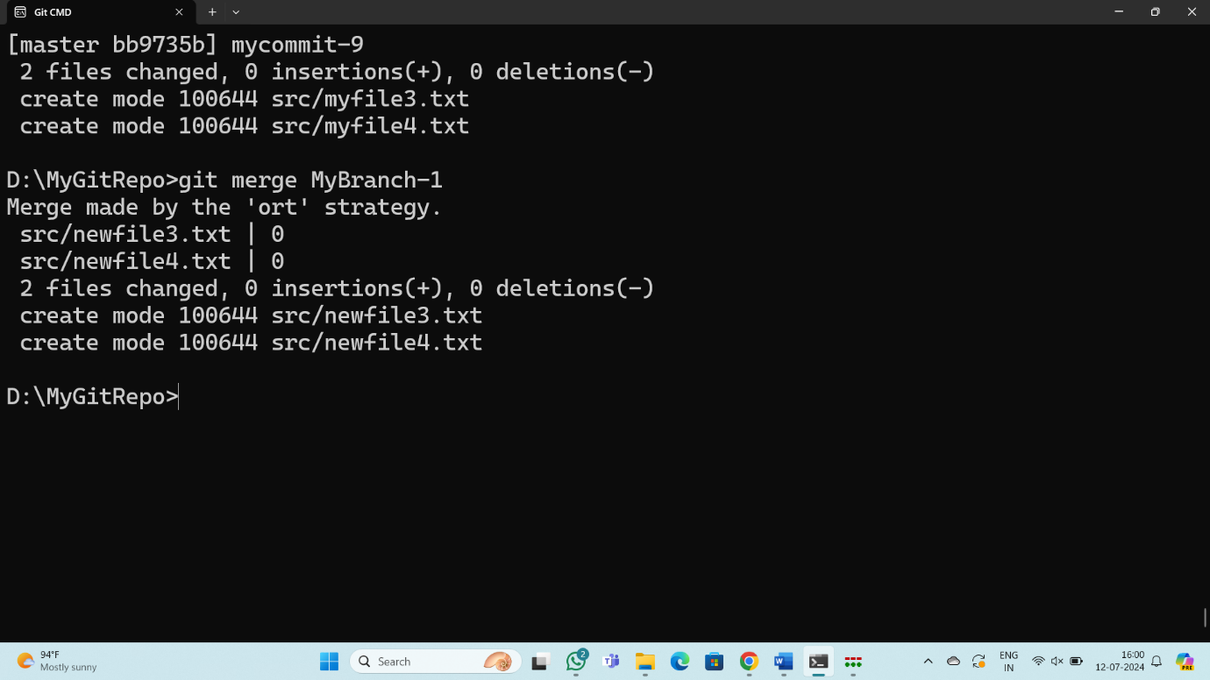Now merge your branch again. (Aside: you don’t need to do anything to inform Git that you only want to merge things added since your previous merge. Due to the way Git works, that kind of issue simply does not come up, unlike in early versions of Subversion.)
12. 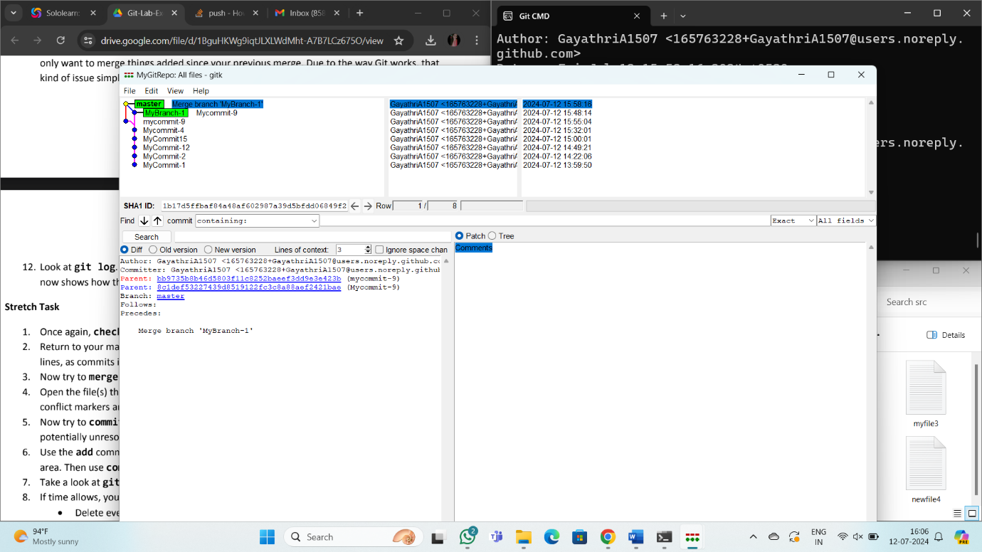Look at git log. Notice that there is a merge commit. Also look in gitk. Notice the DAG now shows how things forked, and then were joined up again by a merge commit.